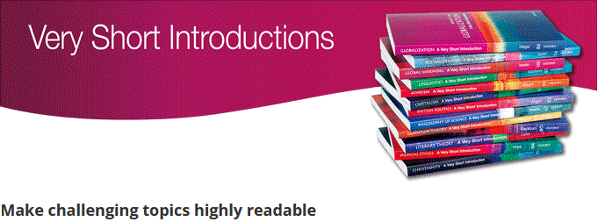
These vibrant and accessible books can change the way you think about the things that interest you, and are the perfect introduction to subjects you previously knew nothing about.
Very Short Introductions make often challenging topics highly readable combining authoritative analysis, new ideas, and enthusiasm.

