Chemical Storage in the Khusnutdinova Unit
CMS: https://cms.oist.jp
When entering chemicals into the system, put two labels on the bottle:
- Barcode (vertically if possible)
- Round label corresponding to hazardous class; write down storage location code!
Color-coded round labels:
DELETERIOUS (MANDATORY to control used amounts) - Red

POISONOUS (MANDATORY to control used amounts) - Green

FLAMMABLE (MANDATORY to control used amounts) - Yellow

OPTIONAL to control used amounts (“Used amount management: optional”) – White

SPECIALLY CONTROLLED WASTE (Blue)– it’s not a hazardous class, but indicates
that we need to separate waste, so just for you information (for halogenated solvents; benzene)
Specially controlled industrial waste chemicals can be deleterious or poisonous, so put two labels and store according to hazardous class (non-hazardous, deleterious, poisonous or flammable).
For example, Carbon Tetrachloride should be labeled as Deleterious, and it’s in a Specially Controlled Waste category. Store it with other Deleterious reagents and put two labels (for example, if it’s stored in Flammable Cabinet 1 tray D1, write down “FC1-D1” on the label):
FC1-D1
Chemicals within each hazardous class should be stored with the same class of chemicals, but they should not be mixed with other classes (deleterious is stored with deleterious in a separate tray/drawer, poisonous with poisonous in a separate tray, etc, but deleterious is not stored together with poisonous or non-hazardous).

Store chemicals according to our storage system and follow common chemical sense – see the list of storage locations.
This is a name of an act, but it doesn’t mean that the chemical is poisonous!

Note:
Hazardous class in indicated here, on the right hand side (in this case, flammable)

How to input TCI and Aldrich chemicals:
Use catalog number on a TCI label shown in the left top corner and search by “product code”:
H0111
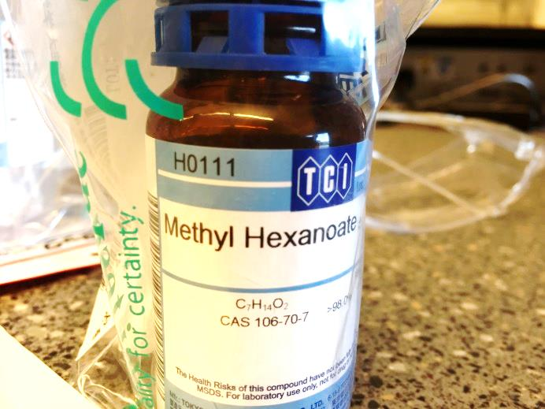

For Aldrich catalog numbers, enter only the first part of the number without amounts and search by “product code”:
514330 (not 514330-100ML!)
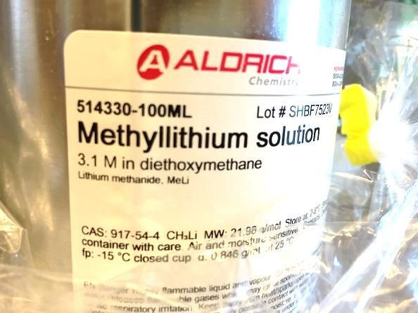

ORGANIC WASTE categories:
- Non-halogenated organic solvents (water content less than 5%)
- Specially controlled industrial waste – includes dichloromethane, carbon tetrachloride and benzene as well as some other common chlorinated solvents. Technically, chloroform is not on the list of specially controlled industrial waste, but if you use small amounts, you can collect it together with dichloromethane waste. If you use large amounts of chloroform, please collect is separately, since the disposal procedure is different (less expensive) compared to specially controlled waste.
Storage in C704
Location | Code
Flammable Cabinet 1, | FC1
Flammable Cabinet 2 | FC2
Hood1A | Hood1A
Hood1B | Hood1B
Hood2A | Hood2A
Hood2B | Hood2B
Hood3A | Hood3A
Hood3B | Hood3B
Hood4A: Non-hazardous (white label) inorganic chemicals (non-corrosive) | Hood4A
Hood4B: for deleterious inorganic chemicals and strong bases | Hood4B
Hood5A | Hood5A
Hood5B | Hood5B
Hood6A | Hood6A
Hood6B | Hood6B
Hood7A | Hood7A
Hood7B | Hood7B
Hood8A | Hood8A
Hood8B | Hood8B
Fridge 1/freezer 1 in C704
Fridge 1 | Code
Fridge 1, tray A | Fr1-A
Fridge 1, tray B | Fr1-A
Fridge 1, tray C | Fr1-A
Fridge 1, D | Fr1-A
Fridge 1, E (bottom compartment) | Fr1-A
Fridge 1, F (door) | Fr1-F
Fridge 1, G (door) | Fr1-F
Fridge 1, H (door) | Fr1-F
Fridge 1, I (door) | Fr1-F
Fridge 1, G (door) | Fr1-F
Fridge 1, K (door) | Fr1-F
Fridge 1, L (door) | Fr1-F
Freezer 1:
Freezer 1, tray A | FZ1-A
Freezer 1, tray B | FZ1-B

Storage in C708
Location | Code
Solvent Purification System | SPS
Glovebox 1, double station (on the left from SPS) | GB1
Glovebox 1 freezer | GB1-Fr
Glovebox 2, single station (on the right from SPS) | GB2
Glovebox 2 freezer | GB2-Fr
Glovebox 3, single station (opposite side to other two) | GB3
Glovebox 3 freezer | GB3-Fr

