***Seminar***

***How the new and old modulate hippocampal function***

**Speaker： Thomas McHugh, Ph.D.**

**RIKEN CENTER FOR BRAIN SCIENCE**

**Team Leader,**

**Circuit and Behavioral Physiology**

**Date: Thursday, December 19, 2024**

**Time: 13:00 – 14:00**

**Location: Lab5 Level D Seminar Room -L5D23**

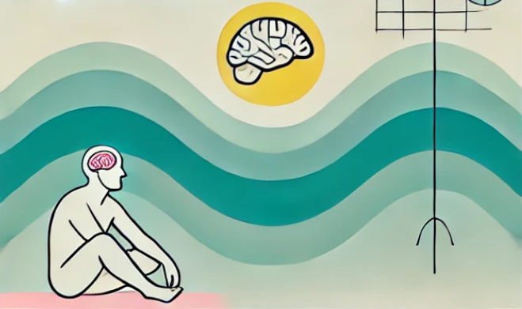

【Abstract】The hippocampus plays a crucial role in episodic memory; the who, what, where memories that define our lives. While novelty is known to facilitate the encoding and duration of experiences, most of what we encounter is familiar and not stored for later use.  Here I will present our recent work in mice which combines anatomical characterization, genetic interventions and in vivo recording to address how noncononical inputs and outputs influence this balance between new and old  . I will first introduce work identifying a novelty signaling hub in the hypothalamus – the supramammillary nucleus (SuM). Unique about this region is that it not only responds broadly to novel stimuli, but segregates and selectively routes different types of information to discrete cortical targets, the dentate gyrus (DG) and CA2 fields of the hippocampus, for the modulation of mnemonic processing. Next, I will describe ongoing work focused on how CA2’s output impacts both local and distal circuits, including our identification and characterization of a descending glutamatergic projection from CA2 pyramidal cells to PV+ neurons in the MS that can regulate cholinergic tone and hippocampal memory.