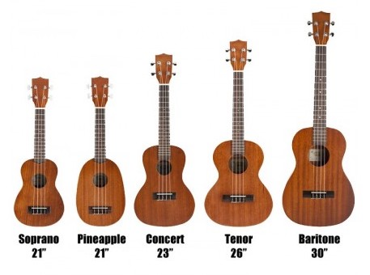
OIST Ukulele Club Songbook
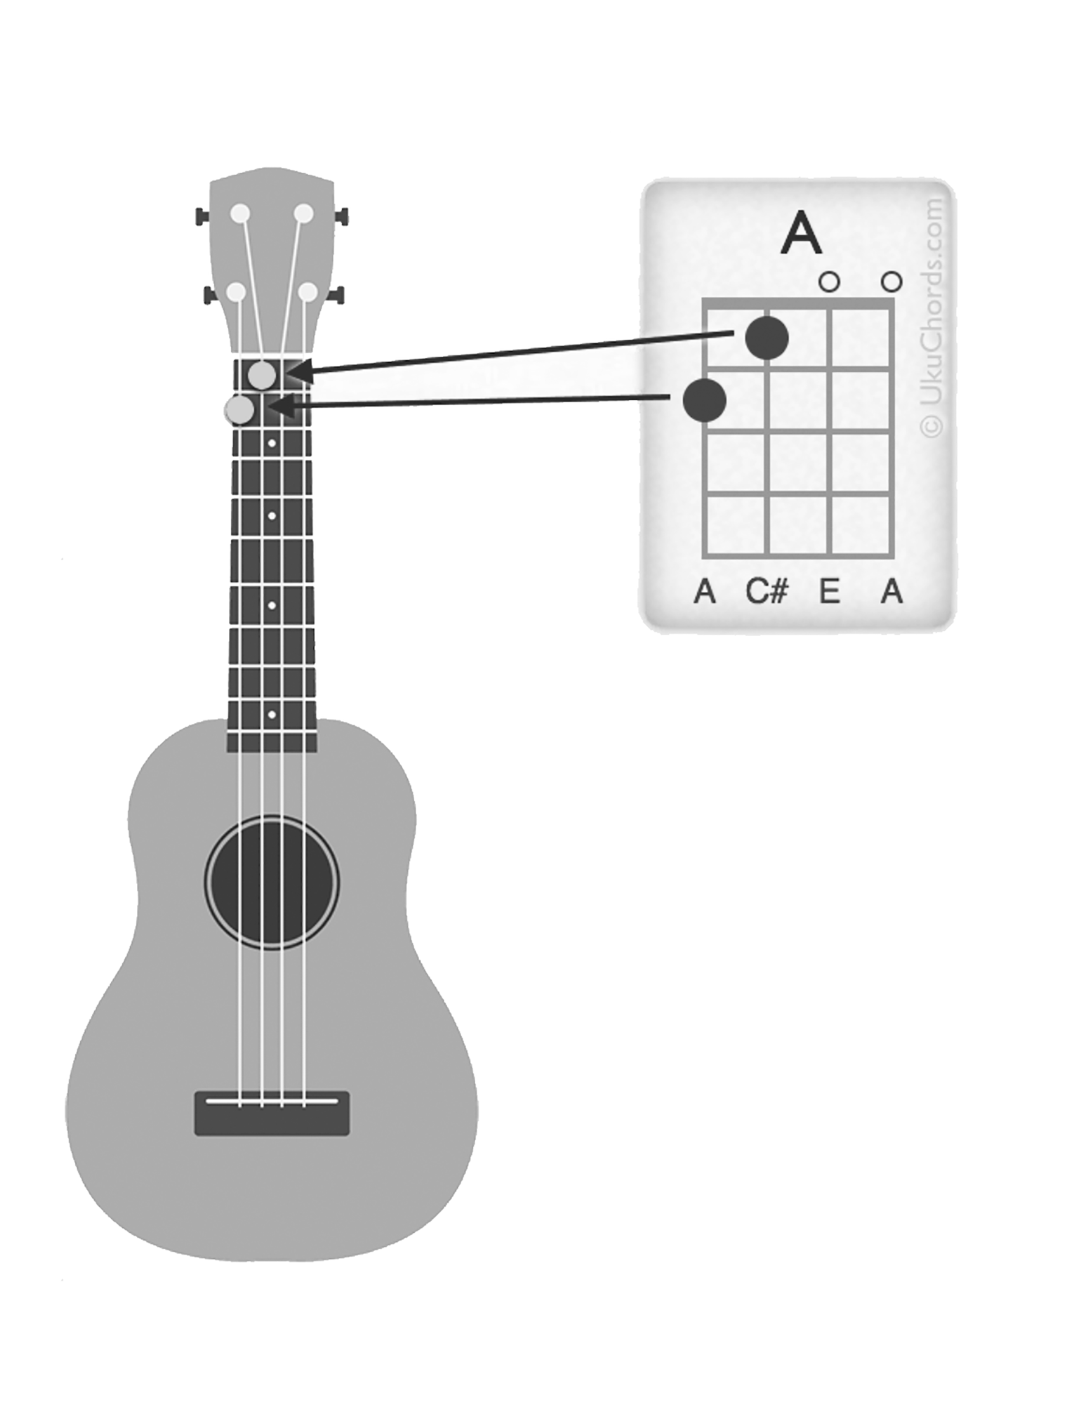
Table of Contents

4. Wrecking Ball – Miley Cyrus
6. Let It Be – The Beatles
8. Island In The Sun - Weezer
10. Oxford Comma – Vampire Weekend
12. Riptide – Vance Joy
14. The Scientist - Coldplay
16. Somebody That I Used To Know - GOTYE
18. What's Up – Four Non Blondes
20. Hey Ho – The Lumineers
22. I'm Gonna Be (500 Miles) – The Proclaimers
24. Ojala Que Llueva Café – Café Tacuba
26. Santa Monica - Everclear
28. Firework – Katy Perry
30. Shake It Off – Taylor Swift
32. Closing Time - Semisonic
34. Please Do Not Go – The Violent Femmes
36. Come As You Are – Nirvana
38. Half A Woman – Fountains of Wayne
40. Lava - Kuana Torres Kahele and Napua Greig
42. Wagon Wheel – Bob Dylan / Darius Rucker
44. The Weight – The Band
46. Have You Ever Seen The Rain? – Creedence Clearwater Revival
47. Stand By Me – Ben E. King
48. Something In The Way – Nirvana
49. Last Leaf – OK GO
50. Creep – Radiohead
51. The Lion Sleeps Tonight – The Tokens

Miley Cyrus – Wrecking Ball

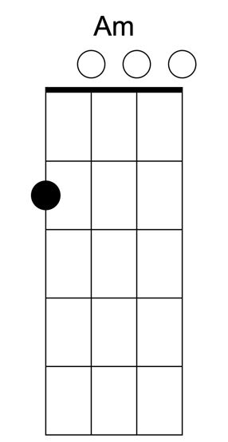 | 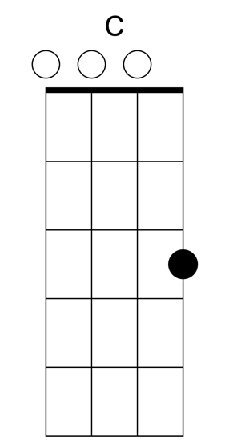 | 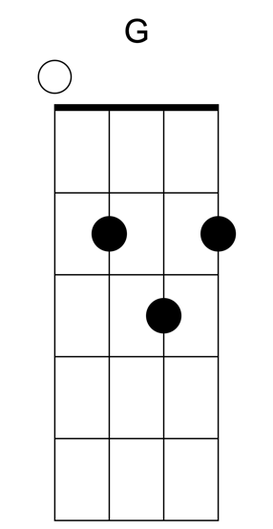 | 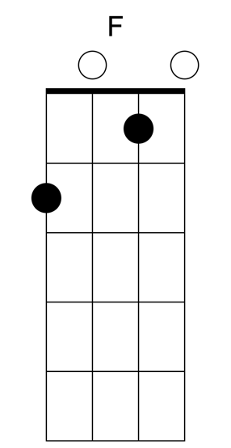 | 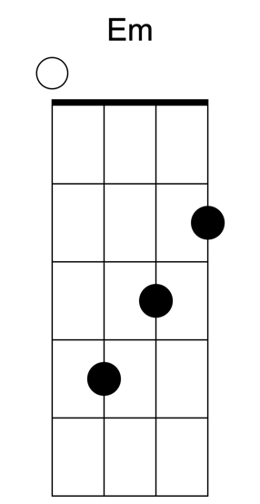

Am C
We clawed, we chained, our hearts in vain
G F
We jumped, never asking why
Am C
We kissed, I fell under your spell
G F
A love no one could deny

Am C
Dont you ever say I just walked away
G F
I will always want you
Am C
I cant live a lie, running for my life
G F
I will always want you

C G
I came in like a wrecking ball
Am F
I never hit so hard in love
C G
All I wanted was to break your walls
Am F
All you ever did was wreck me
Am F
Yeah, you wreck me

Am C
I put you high up in the sky
G F
And now, youre not coming down
Am C
It slowly turned, you let me burn
G F
And now, we’re ashes on the ground

Am C
Don’t you ever say I just walked away
G F
I will always want you
Am C
I cant live a lie, running for my life
G F
I will always want you

C G
I came in like a wrecking ball
Am F
I never hit so hard in love
C G
All I wanted was to break your walls
Am F
All you ever did was wreck me
Am F
Yeah, you wreck me

C G
I came in like a wrecking ball
Am F
I never hit so hard in love
C G
All I wanted was to break your walls
Am F
All you ever did was wreck me
Am F
Yeah, you wreck me

[Bridge]

Am
I never meant to start a war
C
I just wanted you to let me in
Em
And instead of using force
F
I guess I should’ve let you win
Am
I never meant to start a war
C
I just wanted you to let me in
Em
I guess I should’ve let you win

Am C
Dont you ever say I just walked away
G F
I will always want you

C G
I came in like a wrecking ball
Am F
I never hit so hard in love
C G
All I wanted was to break your walls
Am F
All you ever did was wreck me
C G
I came in like a wrecking ball
Am F
Yeah, I just closed my eyes and swung
C G
Left me crouching in a blaze and fall
Am F
All you ever did was wreck me
Am F
Yeah, you wreck me

The Beatles – Let It Be

C G Am F
When I find myself in times of trouble, Mother Mary comes to me
C G F C
Speaking words of wisdom, let it be
C G Am F
And in my hour of darkness, She is standing right in front of me
C G F C
Speaking words of wisdom, let it be

Chorus
Am G F C
Let it be, let it be, let it be, let it be
C G F C
Whisper words of wisdom, let it be

C G Am F
And when the broken hearted people, Living in the world agree
C G F C
There will be an answer, let it be
C G Am F
But though they may be parted, There is still a chance that they will see
C G F C
There will be an answer, let it be

Chorus
Am G F C
Let it be, let it be, let it be, let it be
C G F C
There will be an answer, let it be
Am G F C
Let it be, let it be, let it be, let it be
C G F C
Whisper words of wisdom, let it be
Am G F C
Let it be, let it be, let it be, let it be
C G F C
Whisper words of wisdom, let it be

C G Am F
And when the night is cloudy, there is still a light that shines on me
C G F C
Shine on till tomorrow, let it be
C G Am F
I wake up to the sound of music, Mother Mary comes to me
C G F C
Speaking words of wisdom, let it be

Chorus
Am G F C
Let it be, let it be, let it be, let it be
C G F C
Whisper words of wisdom, let it be
Am G F C
Let it be, let it be, let it be, let it be
C G F C
Whisper words of wisdom, let it be

Weezer – Island in the Sun
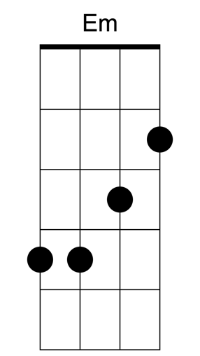 |  | 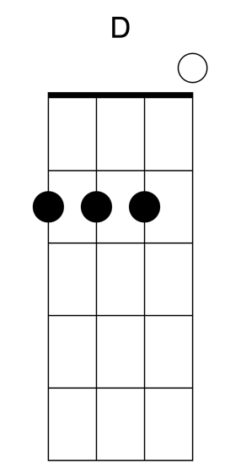

Em Am D G
Hip hip
Em Am D G
Hip hip
Em Am D G
Hip hip
Em Am D G
Hip hip

[Verse]
Em Am D G Em Am
When you're on a holiday
D G Em Am
You can't find the words to say
D G Em Am
All the things that come to you
D G Em Am
And I wanna feel it too

[Chorus]
D G Em Am
On an island in the sun
D G Em Am
We'll be playing and having fun
D G Em
And it makes me feel so fine
Am D G
I can't control my brain

[Interlude]
Em Am D G
Hip hip
Em Am D G
Hip hip

[Verse]
Em Am D G Em Am
When you're on a golden sea
D G Em Am
You don't need no memory
D G Em Am
Just a place to call your own
D G Em Am
As we drift into the zone

[Chorus]
D G Em Am
On an island in the sun
D G Em Am
We'll be playing and having fun
D G Em
And it makes me feel so fine
Am D G
I can't control my brain

[Bridge]
D G
We'll run away together
D G
We'll spend some time forever
C Am D
We'll never feel bad anymore (Hip hip)

[Interlude]

Em Am D G
Hip hip
Em Am D G
Hip hip

[Solo]
Em Am D G
Em Am D G
Em Am D G
Em Am D G

[Chorus]
Em Am D G Em Am
On an island in the sun
D G Em Am
We'll be playing and having fun
D G Em
And it makes me feel so fine
Am D G
I can't control my brain

[Bridge]
D G
We'll run away together
D G
We'll spend some time forever
C Am D
We'll never feel bad anymore

[Outro]
Em Am D G
Hip hip
Em Am D G
Hip hip
(We'll never feel bad anymore)
Em Am D G
Hip hip
Em Am D G
Hip hip (No no)
Em Am D G
Hip hip
Em Am D G
Hip hip
(We'll never feel bad anymore)
Em Am D G
Hip hip
Em Am D G
Hip hip (No no)

Vampire Weekend – Oxford Comma

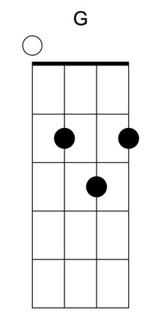 | 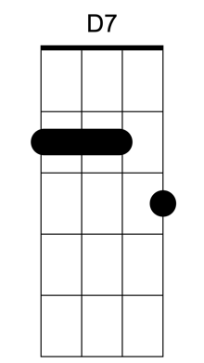 | 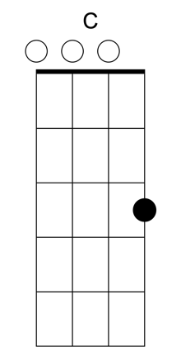 | 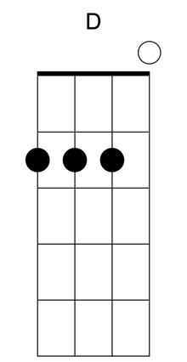 | 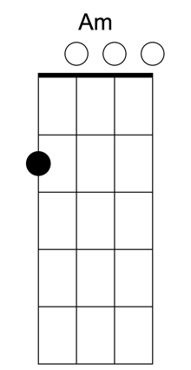

Intro: G

[verse]
G
Who gives a fuck about an Oxford comma?
D7 G
I've seen those English dramas too
C
They're cruel
G
So if there's any other way
D7
To spell the word
G C
It's fine with me, with me

[chorus]
C D
Why would you speak to me that way
G Am
Especially when I always said that I
C D
Haven't got the words for you
G Am
All your diction dripping with disdain
C
Through the pain
D G
I always tell the truth
[verse]
G
Who gives a fuck about an Oxford climber?
D7 G
I climbed to Dharamshala too
C
I did
G
I met the highest lama
D7
His accent sounded fine
G C
to me, to me

[chorus]
C D
Check your handbook it's no trick
G Am
Take the chapstick, put it on your lips
C D
Crack a smile, adjust my tie
G Am
Know your boyfriend, unlike other guys
C D
Why would you lie about how much coal you have?
G Am
Why would you lie about something dumb like that?
C D
Why would you lie about anything at all?
G Am
First the window, then it's to the wall
C D G
Lil' Jon, he always tells the truth

[Solo, same as verse and first part of chorus]
G D7 G C
G D7 G C
G D7 G C
G D7 G C

[Chorus]
C D
Check your passport it's no trick
G Am
Take the chapstick, put it on your lips
C D
Crack a smile, adjust my tie
G Am
Know your butler, unlike other guys
C D
Why would you lie about how much coal you have?
G Am
Why would you lie about something dumb like that?
C D
Why would you lie about anything at all?
G Am
First the window, then it's through the wall
C D
Why would you tape my conversations?
G Am
Show your paintings at the United Nations
C D G
Lil' Jon, he always tells the truth

Vance Joy - Riptide

Am G C (x2)

Am G C
I was scared of dentists and the dark,
Am G C
I was scared of pretty girls and starting conversations
Am G C
Oh all my friends are turning green
Am G
You're the magicians assistant in their
C
dream

Am G C
Ooh, ooh ooh
Am G C (hold)
Ooh, and they come unstuck

Chorus:
Am G C
Lady, running down to the riptide,
Am
taken away to the dark side,
G C
I wanna be your left hand man.
Am G C
I love you when you're singing that song and
Am
I got a lump in my throat 'cause
G C
you're gonna sing the words wrong

Am G C
There's this movie that I think you'll like
Am G C
this guy decides to quit his job and heads to New York City
Am G C
this cowboy's running from himself.
Am G C
And she's been living on the highest shelf
Am G C
Ooh, ooh ooh
Am G C
Ooh, and they come unstuck

Chorus

Am G
I just wanna, I just wanna know,
C F
If you're gonna, if you're gonna stay,
Am G
I just gotta, I just gotta know,
C F
I can't have it, I can't have it any other way

Strum once and hold:
Am G C
I swear she's destined for the screen,
Am G C
Closest thing to Michelle Pfeiffer that you've ever seen, oh

Chorus x 3

Coldplay – The Scientist
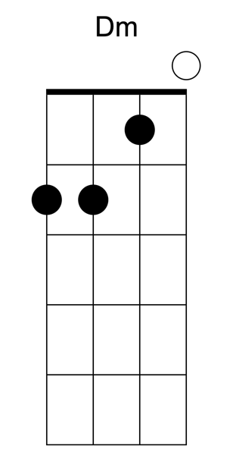 | 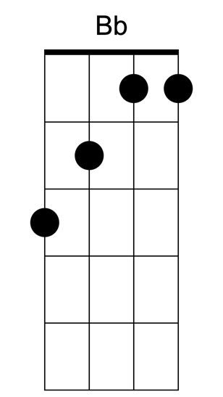 | 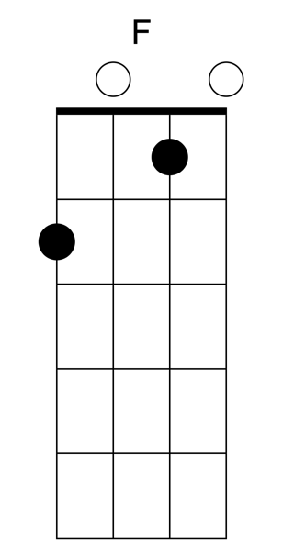
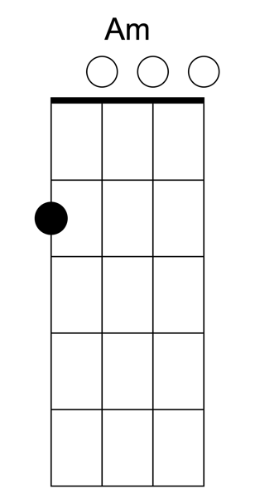 | 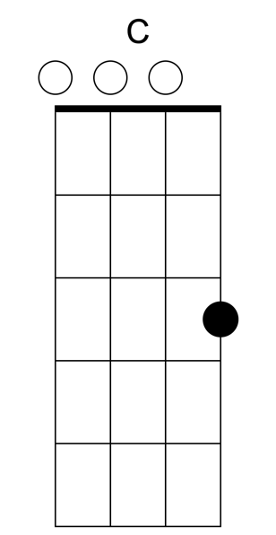 | 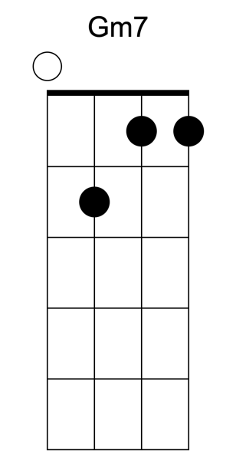

Dm F Am Bb C Gm7

Note: It can be hard to figure out where the melody fits with this one at first, so the melody notes are F-G-F-C-A

[Intro]
Dm F F Am x2

[Verse I]
Dm Bb F
Come up to meet you, tell you I'm sorry
Am Dm
You don't know how lovely you are
Bb F
I had to find you, tell you I need you
Am Dm
Tell you I set you apart
Bb F
Tell me your secrets, and ask me your questions
Am Dm
Oh let's go back to the start
Bb F
Running in circles, coming up tails
Am
Heads on a science apart

[Chorus]
Bb F
Nobody said it was easy
Am
It's such a shame for us to part
Bb F
Nobody said it was easy
Am C
No one ever said that it would be this hard
Gm7 F
Oh take me back to the start

[Interlude]
Dm Bb F F Dm Bb F Am

[Verse II]
Dm Bb F
I was just guessing at numbers and figures
Am Dm
Pulling the puzzles apart
Bb F
Questions of science, science and progress

Am Dm
Do not speak as loud as my heart
Bb F
Tell me you love me, come back and haunt me
Am Dm
Oh and I rush to the start

Bb F
Running in circles, chasing our tails
Am
Coming back as we are

[Chorus]
Bb F
Nobody said it was easy
Am
It's such a shame for us to part
Bb F
Nobody said it was easy
Am C
No one ever said it would be so hard
Gm7 F
I'm going back to the start

[Solo]
Dm Bb F F
Dm Bb F F

[Ending]
Dm Bb F F
Ah-Oooohh...
Dm Bb F F
Ah-Oooohh...
Dm Bb F F
Ah-Oooohh...
Dm Bb F F
Ah-Oooohh...

GOTYE – Somebody That I Used To Know

Dm C Dm C
Now and then I think of when we were
Dm C Dm C
together
Dm C Dm C
Like when you said you felt so happy you
Dm C Dm C
could die
Dm C Dm C
Told myself that you were right for me
Dm C Dm C
But felt so lonely in your company
Dm C Dm C
But that was love and it's an ache I still
Dm C Dm C
remember

Dm C Dm C
You can get addicted to a certain kind of
Dm C Dm C
sadness
Dm C Dm C
Like resignation to the end always
Dm C Dm C
the end
Dm C Dm
So when we found that we could not make
C
sense
Dm C Dm C
Well you said that we would still be friends
Dm C Dm C
But I'll admit that I was glad that it was over

Chorus:
Dm C Bb C
But you didn't have to cut me off
Dm C Bb
Make out like it never happened
C Dm
And that we were nothing
C Bb C
And I don't even need your love
Dm C
But you treat me like a stranger
Bb C
And that feels so rough
Dm C Bb C
No, you didn't have to stoop so low
Dm C Bb
Have your friends collect your records
C Dm
And then change your number
C Bb C
I guess that I don't need that though
Dm C Bb
Now you're just somebody that I used to
C
know
Dm C Bb
Now you're just somebody that I used to
C
know
Dm C Bb
Now you're just somebody that I used to
C
Know

Verse
Dm C Dm
Now and then I think of all the times you
C Dm C Dm C
screwed me over
Dm C Dm
But had me believing it was always
C Dm C Dm C
something that I'd done
C
And I don't wanna live that way
C
Reading into every word you say
C
You said that you could let it go
C
And I wouldn't catch you hung up on
N.C.
somebody that you used to know

Repeat Chorus

Dm C Bb C
Somebody I used to know
Dm C Bb C
Somebody that I used to know

Dm C Bb
Now you're just somebody that I used to
C
know

Four Non Blondes – What’s Up

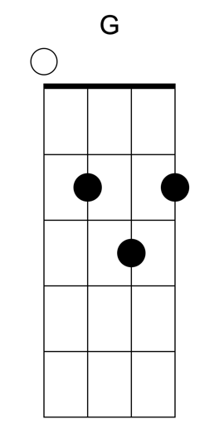 | 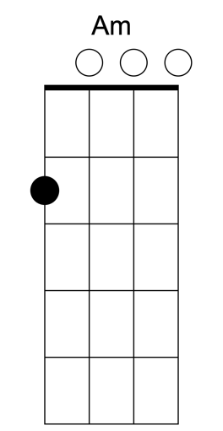 | 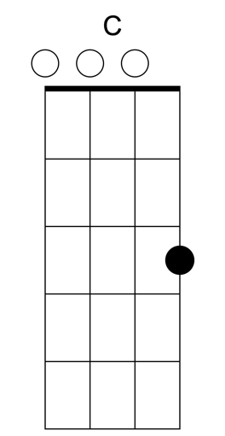

[intro] G Am C G

G
25 years of my life and still
Am
Trying to get up that great big hill of
C G
Hope For a destination
G
I realized quickly when I knew I should
Am
That the world was made for this
C
brotherhood of man
G
For whatever that means

[chorus]
G
And so I cry sometimes when I'm lying in bed
Am
Just to get it all out, what's in my head
C G
And I, I'm feeling A little peculiar
G
And so I wake in the morning and I step outside
Am
And I take deep breath and I get real high
C
And I scream to the top of my lungs
G
What's goin' on?
G Am
And I say hey-yeah-yeah-yeah, Hey yea yea
C G
I say hey What's goin' on?
Am
And I say hey-yeah-yeah-yeah, Hey yea yea
C G
I say hey What's goin' on?

G Am C G
Oooh, oo!.. oo oo- Oo-hoo hoo hoo hoo

G Am
And I try Oh my God do I try
C G
I try all the time In this institution
G Am
And I pray, Oh my God do I pray
C G
I pray every single day For revolution

[repeat chorus]

[single strums]
G
25 years of my life and still
Am
Trying to get up that great big hill of
C G
Hope For a destination

Lumineers – Hey Ho
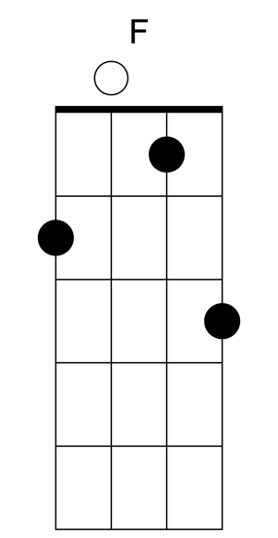

You’ll notice the F chord here is a bit different from the one you see more commonly; it has a C on the A string instead of an open A. Both notes are in an F chord so it’s still an F, it’s just played this way here to make it easier to switch from F to C really fast.

Intro
F C F
(Ho!)
C F
(Hey!)
C F
(Ho!)
C F
(Hey!)

C F
(Ho!) I've been trying to do it right
C F
(Hey!) I've been living a lonely life
C F
(Ho!) I've been sleeping here instead
C
(Hey!) I've been sleeping in my bed,
Am G F C F
(Ho!) sleeping in my bed (Hey!)

C F
(Ho!) So show me family
C F
(Hey!) Or the blood that I would bleed
C F
(Ho!) I don't know where I belong
C
(Hey!) I don't know where I went wrong
Am G F C
(Ho!) But I can write a song (Hey!)

Chorus
Am G
I belong with you, you belong with me,
C
you're my sweetheart
Am G
I belong with you, you belong with me,
F C F
you're my sweet (Ho!)

Repeat Intro

C F
(Ho!) I don't think you're right for him
C F
(Hey!) Think of what it might've been if we
C F
(Ho!) Took a bus to Chinatown
C
(Hey!) I'd be standing on Canal
Am G F
(ho!) and Bowery
C
(Hey!)
Am G C(Ho!) She'd be standing next to me (hey!)

Repeat Chorus x2

F G C
'Cause love we need it now
F G
Let's hope for some
F G C
'Cause oh, we're bleeding out

Repeat Chorus

Repeat Intro

The Proclaimers – I’m Gonna Be (500 Miles)

 | 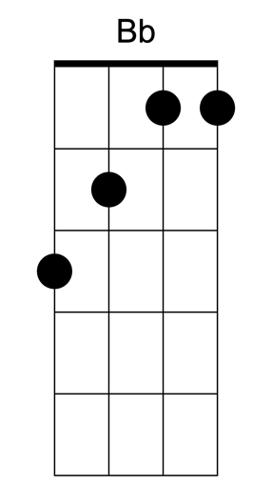 |  | 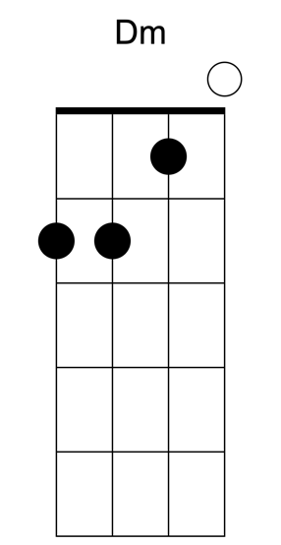 | 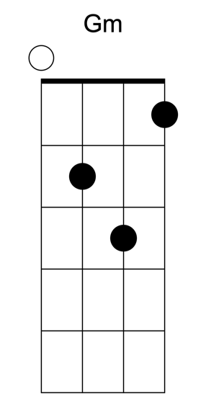

Intro: F

F
When I wake up yeah I know I'm gonna be
Bb C F
I'm gonna be the man who wakes up next to you
F
When I go out yeah I know I'm gonna be
Bb C F
I'm gonna be the man who goes along with you
F
If I get drunk yes I know I'm gonna be
Bb C F
I'm gonna be the man who gets drunk next to you
F
And if I haver yeah I know I'm gonna be
Bb C F
I'm gonna be the man who's havering to you

[Chorus]
F
But I would walk 500 miles
Bb C
And I would walk 500 more
F Bb
Just to be the man who walked 1,000 miles
C
To fall down at your door

F
When I'm working yes I know I'm gonna be
Bb C F
I'm gonna be the man who's working hard for you
F
And when the money comes in for the work I'll do
Bb C F
I'll pass almost every penny on to you
F
When I come home yeah I know I'm gonna be
Bb C F
I'm gonna be the man who comes back home to you
F
And if I grow old well I know I'm gonna be
Bb C F
I'm gonna be the man who's growing old with you

F
But I would walk 500 miles
Bb C
And I would walk 500 more
F Bb
Just to be the man who walked 1,000 miles
C
To fall down at your door
F
Da da da (da da da) Da da da (da da da)
Bb C F
Da da da dun diddle un diddle un diddle uh da
F
Da da da (da da da) Da da da (da da da)
Bb C F
Da da da dun diddle un diddle un diddle uh da

F
When I'm lonely yes I know I'm gonna be
Bb C F
I'm gonna be the man who's lonely without you
F
When I'm dreaming well I know I'm gonna dream
Bb C F
I'm gonna dream about the time when I'm with you.
F
When I go out, well I know I'm gonna be
Bb C F
I'm gonna be the man who goes along with you
F
And when I come home, yes I know I'm gonna be
Bb C
I'm gonna be the man who comes back home
Dm
with you
Gm C
I'm gonna be the man who's coming home with
F
you

F
But I would walk 500 miles
Bb C
And I would walk 500 more
F Bb
Just to be the man who walked 1,000 miles
C
To fall down at your door
F
Da da da (da da da) Da da da (da da da)
Bb C F
Da da da dun diddle un diddle un diddle uh da
F
Da da da (da da da) Da da da (da da da)
Bb C F
Da da da dun diddle un diddle un diddle uh da
F
Da da da (da da da) Da da da (da da da)
Bb C F
Da da da dun diddle un diddle un diddle uh da
F
Da da da (da da da) Da da da (da da da)
Bb C F
Da da da dun diddle un diddle un diddle uh da
F
And I would walk 500 miles
Bb C
And I would walk 500 more
F Bb
Just to be the man who walked 1,000 miles
C F
To fall down at your door

Café Tacuba – Ojala Que Llueva Cafe

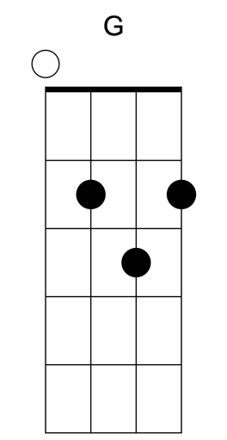 | 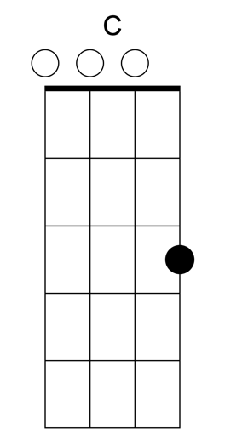 | 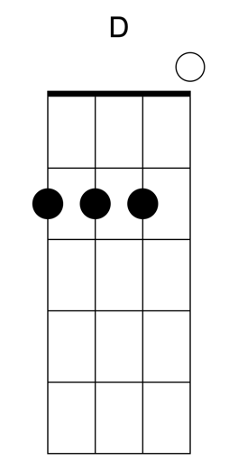 | 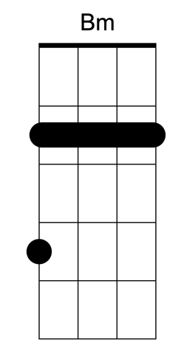 | 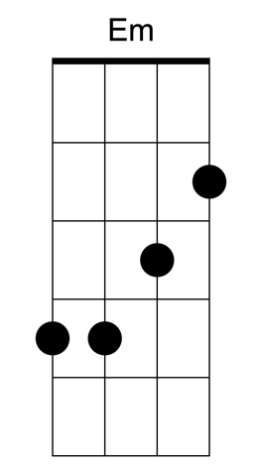

Intro: G G C D x 2

G C D
Ojalá que llueva café en el campo
G C D
Que caiga un aguacero de yuca y té
G C D
Del cielo una jarina de queso blanco
G C D
Y al sur una montaña de berro y miel
C D Bm Em
Oh oh, wo oh oh
C D G
Ojalá que llueva café

G C D
Ojalá que llueva café en el campo
G C D
Peinar un alto cerro de trigo y mapuey
G C D
Baja' por la colina de arroz graneado
G C D
Y continua el arado con tu querer
C D Bm Em
Oh oh, wo oh oh

C D G C
Ojalá el otoño en vez de hojas secas
C D G C
Pinta mi cosecha’e pitisalegre
C D G C
Siembra una llanura de patata y fresas
C D
Ojalá que llueva café

(instrumental part that we probably won’t try)

C G
Ojalá que llueva café en el campo
D G
Peinar un alto cerro de trigo y mapuey
C G
Bajar por la colina de arroz graneado
D G
Y continua el arado con tu querer
C G
Ay laralalalai! ay larala,
D G
Ay laralalai, ojalá que llueva café

C G
Pa' que en la realidad no se sufra tanto,
D G
Ojalá que llueva café en el campo
C G
Pa' que en Villa Hidalgo oigan este canto,
D G
Ojalá que llueva café en el campo

C G
Pa' que to'os los niños canten este canto,
D G
Ojalá que llueva café en el campo

C G
Ojalá que llueva, ojalá que llueva
D G
Ojalá que llueva café en el campo

Everclear – Santa Monica
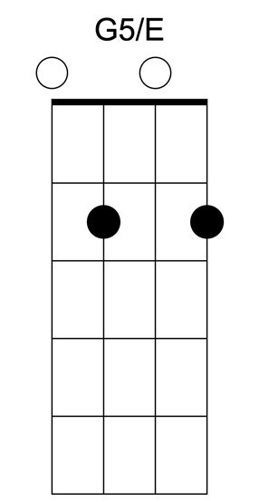

The main riff of this song which is going through the intro, the outro, and any time during the verse when it says “G riff” is strummed like this:

G G x x G G G/E G/E

If that’s too difficult, you can just play a G through all of it and you’ll be fine.

Intro:
G riff 3x
G and rest

[Verse]
G riff
I am still living with your ghost
Lonely and dreaming of the west coast
D C
I don't want to be your downtime
G riff
I don't want to be your stupid game
With my big black boots and an old suitcase
I do believe I'll find myself a new place
D C
I don't want to be the bad guy
G riff
I don't want to do your sleepwalk dance anymore

D C
I just want to see some palm trees
G riff
Go and try to shake away this disease

[Chorus]
C
We can live beside the ocean
G
Leave the fire behind
D
Swim out past the breakers
G
Watch the world die

[Verse]
G riff
I am still dreaming of your face
Hungry and hollow for all the things you took away
D C
I don't want to be your good time
G riff
I don't want to be your fall-back crutch anymore
I'll walk right out into a brand new day
Insane and rising in my own weird way

D C
I don't want to be the bad guy
G riff
I don't want to do your sleepwalk dance anymore
D C
I just want to feel some sunshine
G riff
I just want to find some place to be alone

[Chorus – Repeat 4x]
C
We can live beside the ocean

G
Leave the fire behind
D
Swim out past the breakers
G
Watch the world die

G riff
Yeah watch the world die
G riff
Yeah watch the world die
G riff
Yeah watch the world die
G riff G
Yeah watch the world die

Katy Perry - Firework
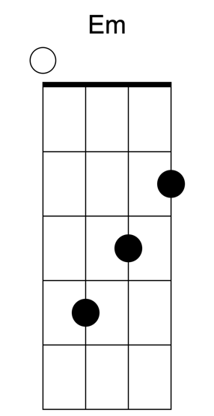

[Intro]
G Am Em C

[Verse]
G Am
Do you ever feel like a plastic bag,
Em
drifting through the wind
C
wanting to start again?
G Am
Do you ever feel, feel so paper thin
Em
like a house of cards,
C
one blow from caving in?
G Am
Do you ever feel already buried deep?
Em C
6 feet under screams but no one seems to hear a thing
G Am
Do you know that there's still a chance for you
Em
'Cause there's a spark in you
C
You just gotta

[Chorus]
G Am Em C
Ignite, the light, and let it shine
G Am Em C
Just own the night like the 4th of July
G Am
'Cause baby you're a firework
Em C
Come on, show 'em what you're worth
G Am
Make 'em go "Oh, oh, oh"
Em C
As you shoot across the sky-y-y
G Am
Baby, you're a firework
Em C
Come on, let your colors burst
G Am
Make 'em go "Oh, oh, oh"
Em C
You're gonna leave 'em all in awe, awe, awe

[Verse]
G Am
You don't have to feel like a waste of space
Em C
You're original, cannot be replaced
G Am
If you only knew what the future holds
Em C
After a hurricane comes a rainbow
G Am
Maybe your reason why all the doors are closed
Em C
So you could open one that leads you to the perfect road
G Am
Like a lightning bolt, your heart will blow
Em
And when it's time, you'll know
C
You just gotta

[Chorus]
G Am Em C
Ignite, the light, and let it shine
G Am Em C
Just own the night like the 4th of July
G Am
'Cause baby you're a firework
Em C
Come on, show 'em what you're worth
G Am
Make 'em go "Oh, oh, oh"
Em C
As you shoot across the sky-y-y
G Am
Baby, you're a firework
Em C
Come on, let your colors burst
G Am
Make 'em go "Oh, oh, oh"
Em C
You're gonna leave 'em all in awe, awe, awe

[Bridge]
Em
Boom, boom, boom
C
Even brighter than the moon, moon, moon
G
It's always been inside of you, you, you
D
And now it's time to let it through-ough-ough

[Chorus]
G Am
'Cause baby you're a firework
Em C
Come on, show 'em what you're worth
G Am
Make 'em go "Oh, oh, oh"
Em C
As you shoot across the sky-y-y
G Am
Baby, you're a firework
Em C
Come on, let your colors burst
G Am
Make 'em go "Oh, oh, oh"
Em C
You're gonna leave 'em all in awe, awe, awe

[Outro]
G Am
Boom, boom, boom
Em C
Even brighter than the moon, moon, moon
G Am
Boom, boom, boom
Em C
Even brighter than the moon, moon, moon

Taylor Swift – Shake It Off

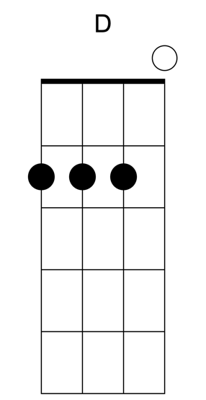

Intro: G

Am
I stay out too late
C
Got nothing in my brain
G
That's what people say, mmm
That's what people say, mmm
Am
I go on too many dates
C
But I can't make 'em stay
G
At least that's what people say, mmm
That's what people say, mmm

Am
But I keep cruisin'
C
Can't stop won't stop moving
G
It's like I got this music in my mind
Saying it's gonna be alright

Chorus:
Am
Cause the players gonna play, play, play, play, play
C
And the haters gonna hate, hate, hate, hate, hate baby
G
I'm just gonna shake, shake, shake, shake, shake
Shake it off, I shake it off
Am
Heart breakers gonna break, break, break, break, break
C
And the fakers gonna fake, fake, fake, fake, fake baby
G
I'm just gonna shake, shake, shake, shake, shake
Shake it off, I shake it off

Am
I never miss a beat
C
I'm lightning on my feet
G
And that's what they don’t see, mmm
That's what they don’t see, mmm
Am
I'm dancing on my own
C
I'll make the moves up as I go
G
And that's what they don't know, mmm
That's what they don't know, mmm
Am
But I keep cruisin'
C
Can't stop won't stop groovin'
G
It's like I got this music in my mind
Saying it's gonna be alright

Chorus

Am
Shake it off, I shake it off, I I
C
I shake it off, I shake it off, I I
G
I shake it off, I shake it off, I I
I shake it off, I shake it off

N.C., Spoken:
Hey, hey, hey, just think
While you've been gettin' down and out
About the liars and dirty, dirty cheats of the world
You could've been gettin' down to this sick beat

My ex man brought his new girlfriend
She's like "Oh my God"
I 'm just gonna shake it
To the fella over there with the hella good hair
Won't you come on over baby we could shake shake shake

Ye--ah ohhh!

Chorus

Am
Shake it off, I shake it off, I I
C
I shake it off, I shake it off, I I
G
I shake it off, I shake it off, I I
I shake it off, I shake it off

Am
Shake it off, I shake it off, I I
C
I shake it off, I shake it off, I I
G
I shake it off, I shake it off, I I
I shake it off, I shake it off

Am
Shake it off, I shake it off, I I
C
I shake it off, I shake it off, I I
G
I shake it off, I shake it off, I I

I shake it off, I shake it off

Semisonic – Closing Time

Intro: G D Am C x 4

G D
Closing time
Am C
Open all the doors and let you
G D Am C
out into the world
G D
Closing time
Am C
Turn all of the lights on over
G D Am C
every boy and every girl
G D
Closing time
Am C
One last call for alcohol so
G D Am C
finish your whiskey or beer
G D
Closing time
Am C
You don't have to go home but you
G D Am C
can't stay here

[Chorus]
G D Am C
I know who I want to take me home
G D Am C
I know who I want to take me home
G D Am C
I know who I want to take me home
G D Am C
Take me home

G D
Closing time
Am C
Time for you to go out to the
G D Am C
places you will be from
G D
Closing time
Am C
This room won't be open till your
G D Am C
brothers or your sisters come

G D
So gather up your jackets
Am C
move it to the exits
G D Am C
I hope you have found a friend
G D
Closing time
Am C
Every new beginning comes from
G D Am C
some other beginning's end...yeah

Chorus

Solo: G D Am C x 4

G D
Closing time
Am C
Time for you to go out to the
G D Am C
places you will be from

Chorus x 2

G D
Closing time
Am C G D Am C G
Every new beginning comes from some other beginning's end

Violent Femmes – Please Do Not Go

G C D
Tell ya, man, I'm stuck on this lovely girl
G C D
‘Cuz to me, she mean all t' world
G C D
But then she like another guy
G C
I fall down dead, she never see the tears I
D
cry

Chorus
G C D
Say please, please, please do not go
G C D
Please, please, please do not go
G C D G
Please, please, please do not go
C G
How long can the days go on
C G
When my love is so strong?
C G
And I know I cannot tell a lie
C D
I want to see him go bye
Bye, bye bye bye-bye

G C
Now I wonder, I wonder what she would
D
say
G C D
If I told her, if I told her I felt this way
G
You know it might make her turn, might
C D
make her turn, might make her turn either way
G C D
So all I can do is patiently pray, pray, pray, pray, pray

Chorus

(Spoken)
G C
I'll tell you, man, I'm stuck, I'm stuck, I'm
D
stuck on this lovely girl
G C
And y'know I'd travel, I could travel over the
D
whole world

G C
And you know what she does, she turn
D
around and like another guy
G C
I fall down dead, she never see the tears I
D
cry

G C D
Please, please, please do not go
G C D
Please, please, please do not go
G C D
Please, please, please do not go
G C D
Please, please, please do not go
G C D
Please, please, please you hurt me so
G C D
Please, please, please you hurt me so
G
Please, please, please I’ve got something to
C D
show you
….repeat and fade out

Nirvana – Come As You Are
 |  | 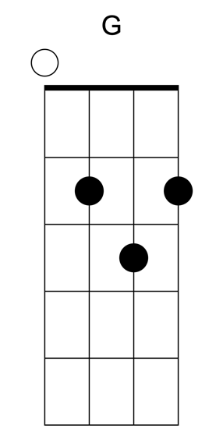 | 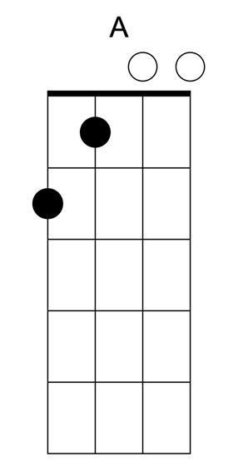

Em D Em
Come as you are, as you were
D Em
As I want you to be
D Em
As a friend, as a friend
D Em
As an old enemy
D Em
Take your time, hurry up
D Em
Choice is yours, don't be late
D Em
Take a rest as a friend
D Em G
As an old memory-a
Em G
Memory-a
Em G
Memory-a
Em G
Memory-a

Em D Em
Come doused in mud, soaked in bleach
D Em
As I want you to be
D Em
As a trend, as a friend
D Em G
As an old memory-a
Em G
Memory-a
Em G
Memory-a
Em G
Memory-a

A C A C
And I swear that I don't have a gun
A C
No, I don't have a gun
A C
No, I don't have a gun

[Guitar Solo]
Em D x 4

Em G
Memory-a
Em G
Memory-a
Em G
Memory-a
A C A C
And I swear that I don't have a gun
A C
No, I don't have a gun
A C
No, I don't have a gun
A C
No, I don't have a gun

A C
No, I don't have a gun

Em D Em D

Em
Memory-a
Memory-a

Fountains of Wayne – Half a Woman
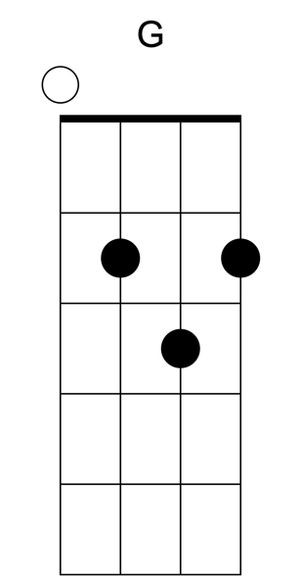 | 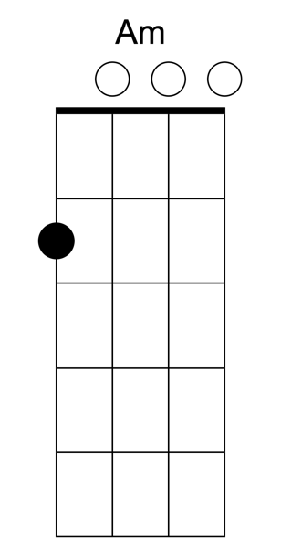 | 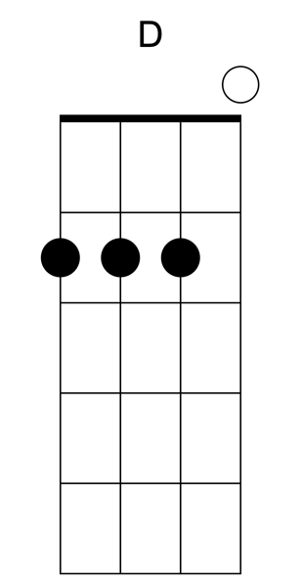
 | 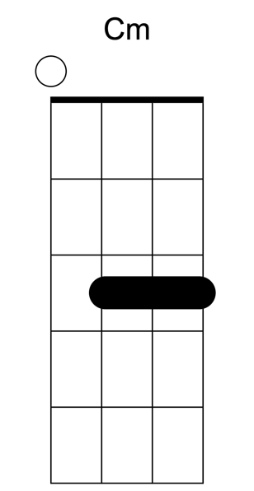 | 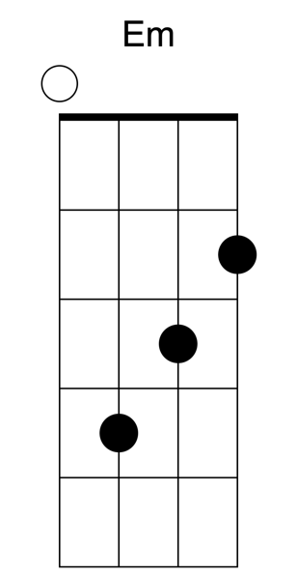

G
They called him Great Scott because he was great
Am
They called her Great Susan 'cause she was his date
G D
She climbed in a box, he cut her in two
C Cm
And when he was through she was just half
G
a woman

G
He’d tie her up, set her on fire
Am
He'd douse her with oil, the crowd would go wild
G
She was always all right at the end of the
D
night
C Cm
But somehow she felt like just half a
G
woman

Em G
The show went the same way year after year
Em G
He'd wave his magic wand, and she'd disappear
Em G
One day she asked, "How did this come to be
Am C D
Somewhere there must be more to me”

G
And one day she left, she climbed through the stage
Am
And into the trap door under the lion's cage
G D
And after a spell he said, "What the hell.
C Cm
It was just as well. She was just half a
G
woman."
Kuana Torres Kahele and Napua Greig - Lava

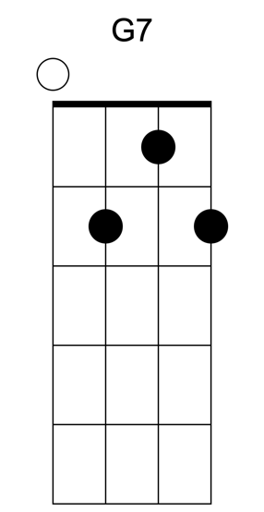

C G7
a long long time ago, there was a volcano.
F C G7
Living all alone, in the middle of the sea.
C G7
He sat high above his bay, watching all the couples play,
F C G7
and wishing that, he had someone too.
C G7
And from his lava came this song of hope
F
that he sang out-loud every day,
C G7
for years and years.

Chorus:
F C
I have a dream I hope will come true,
G7 C
that you’re here with me and I’m here with you.
F C
I wish that the earth, sea, the sky up above
F G7 C
will send me someone to lava.

Verse:
C G7
Years of singing all alone turned his lava into stone
F C G7
until he was on the brink of extinction.
C G7
But little did he know that living in the sea below
F C G7
another volcano was listening to his song.
C G7
Every day she heard his tune. Her lava grew and grew
F C
because she believed his song was meant
G7
for her.
C G7
Now she was so ready to meet him above the sea
F C
as he sang his song of hope for the last
G7
time.

Chorus:
F C
I have a dream I hope will come true,
G7 C
that you’re here with me and I’m here with you.
F C
I wish that the earth, sea, the sky up above
F G7 C
will send me someone to lava.

Verse:
C G7
Rising from the sea below stood a lovely volcano
F C
looking all around but she could not see
G7
him.
C G7
He tried to sing to let her know that she was not there alone,
F C G7
but with no lava his song was all gone.
C G7
He filled the sea with his tears and watched his dreams disappear
F C
as she remembered what his song meant to
G7
her.

Chorus:
F C
I have a dream I hope will come true,
G7 C
that you’re here with me and I’m here with you.

F C
I wish that the earth, sea and the sky up above
F G7 C
will send me someone to lava.

Verse:
C G7
Oh they were so happy to finally meet above the sea,
F C G7
all together now their lava grew and grew.
C G7
No longer are they alone with Aloha as their new home,
F C
and when you visit them, this is what they
G7
sing…

Chorus -Female + Male-:
F C
I have a dream I hope will come true.
G7
That you'll grow old with me,
C
and I'll grow old with you.
F C
We thank the earth, sea, and sky we thank too.

Outro:
F G7 C
I lava YOU!
F G7 C
I lava YOU!
F G7 C
I lava YOU!

Bob Dylan and/or Darius Rucker – Wagon Wheel

[Intro]
G D Em C
G D Em C
G D C

[Verse]
G D
Heading down south to the land of the pines
Em C
I'm thumbing my way into North Caroline
G D C
Staring up the road and pray to God I see headlights
G D
I made it down the coast in seventeen hours
Em C
Picking me a bouquet of dogwood flowers
G D C
And I'm a-hopin' for Raleigh, I can see my baby tonight

[Chorus]
G D
So rock me momma like a wagon wheel
Em C
Rock me momma any way you feel
G D C
Hey, momma rock me
G D
Rock me momma like the wind and the rain
Em C
Rock me momma like a south bound train
G D C
Hey, momma rock me

[Instrumental]
G D Em C
G D C

[Verse]
G D
Running from the cold up in New England
Em C
I was born to be a fiddler in an old time string band
G D C
My baby plays a guitar, I pick a banjo now
G D
Oh, north country winters keep a-getting me down
Em C
I lost my money playing poker so I had to leave town
G D C
But I ain't turning back to living that old life no more

[Chorus]
G D
So rock me momma like a wagon wheel
Em C
Rock me momma any way you feel
G D C
Hey, momma rock me
G D
Rock me momma like the wind and the rain
Em C
Rock me momma like a south bound train
G D C
Hey, momma rock me

[Instrumental]
G D Em C
G D C
G D Em C
G D C

[Verse]
G D
Walkin' to the south out of Roanoke
Em C
I caught a trucker out of Philly had a nice long toke

G D
But he's a heading west from the Cumberland gap
C
To Johnson City, Tennessee
G D
And I gotta get a move on before the sun
Em C
I hear my baby calling my name and I know that she's the only one
G D C
And if I died in Raleigh at least I will die free

[Chorus] (one strum each chord below)
G D
So rock me momma like a wagon wheel
Em C
Rock me momma any way you feel
G D C
Hey, momma rock me
G D
Rock me momma like the wind and the rain
Em C
Rock me momma like a south bound train
G D C
Hey, momma rock me

(normal strumming)
G D
So rock me momma like a wagon wheel
Em C
Rock me momma any way you feel
G D C
Hey, momma rock me
G D
Rock me momma like the wind and the rain
Em C
Rock me momma like a south bound train
G D C G D Em C
Hey, momma rock me

The Band – The Weight
 | 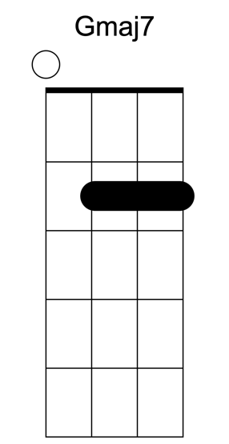
 | 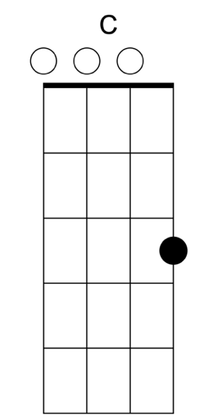 | 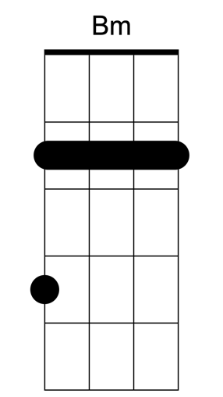

Verse:
G Bm
I pulled into Nazareth
C G
Was feeling 'bout half past dead
G Bm
I just need some place
C G
Where I can lay my head
G Bm
"Hey, mister, can you tell me
C G
Where a man might find a bed?"
G Bm
He just grinned and shook my hand
C G
And "No" was all he said
Chorus:
G Gmaj7 C
Take a load off Fanny
G Gmaj7 C
Take a load for free
G Gmaj7 C
Take a load off Fanny
C G
And (and, and) you put the load right on me
(You put the load right on me)

Instrumental: G Gmaj7 Em D C

G Bm
I picked up my bag
C G
I went looking for a place to hide
Bm
When I saw Carmen and the Devil
C G
Walking side by side
Bm C
I said "Hey Carmen, come on
G
Let's go downtown?"
Bm
And she said, "I gotta go
C G
But my friend can stick around"

Chorus

Instrumental: G Gmaj7 Em D C

G Bm C
Go down, Miss Moses, there's nothin' you
G
can say
Bm C
It's just ol' Luke, and Luke's waitin' on the
G
Judgement Day
Bm C
"Well, Luke, my friend, what about young
G
Anna Lee?"
Bm C
He said, "Do me a favor, son, won't ya stay
G
and keep Anna Lee company?"

Chorus

Instrumental: G Gmaj7 Em D C

G Bm C
Crazy Chester followed me, and he caught
G
me in the fog
Bm C
He said, "I will fix your rack, if you'll take
G
Jack, my dog."
Bm
I said, "Wait a minute, Chester, you know
C G
I'm a peaceful man."
Bm C
He said, "That's okay, boy, won't you feed
G
him when you can."

Chorus

Instrumental: G Gmaj7 Em D C

G Bm C
Catch a Cannonball, now, to take me down
G
the line
Bm C
My bag is sinkin' low and I do believe it's
G
time
Bm C
To get back to Miss Fanny, you know she's
G
the only one
Bm C
Who sent me here with her regards for
G
everyone

Chorus

Instrumental TWICE: G Gmaj7 Em D C

CCR – Have You Ever Seen The Rain?

Intro: C G x 2

C
Someone told me long ago
G
There's a calm before the storm, I know
C
It's been coming for some time
C
When it's over, so they say
G
It'll rain a sunny day, I know
C
Shining down like water

Chorus
F G
I wanna know
C Am
Have you ever seen the rain
F G
I wanna know
C Am
Have you ever seen the rain
F G C G
Coming down on a sunny day

C
Yesterday and days before
G
Sun is cold and rain is hard, I know
C
Been that way for all my time
C
'Til forever on it goes
G
Through the circle fast and slow, I know
C
It can't stop, I wonder

Repeat Chorus x 2

Ben E. King – Stand By Me

G Em
When the night has come and the land is dark
C D G
And the moon is the only light we'll see
Em
No, I won't be afraid, no, I won't be afraid
C D G
Just as long as you stand, stand by me. So darlin', darlin'

G Em
stand by me, oh now stand by me,
C D G
stand by me, stand by me.

G Em
If the sky that we look upon should tumble and fall
C D G
And the mountain should crumble to the sea

Em
I won’t cry, I won’t cry, no I won’t shed a tear
C D G
Just as long as you stand, stand by me. So darlin', darlin'

G Em
stand by me, oh now stand by me,
C D G
stand by me, stand by me.

[Solo]
G Em C D
G Em C D

G Em
stand by me, oh now stand by me,
C D G
stand by me, stand by me.

Nirvana – Something In The Way

Whole song:

Em C

[verse]
Underneath the bridge
Tarp has sprung a leak, and the
Animals I’ve trapped
Have all become my pets, and I’m
Living off of grass, and the
Drippings from the ceiling
It’s okay to eat fish, ‘cause they
Don’t have any feelings

[chorus]
Something in the way, mmmm
Something in the way, yeah, mmmm
Something in the way, mmmm
Something in the way, yeah, mmmm

Repeat verse

Repeat chorus x 2

Ok Go – Last Leaf

 | 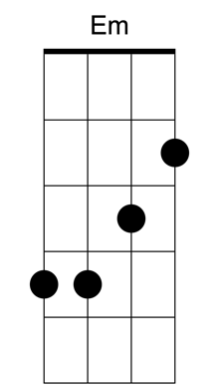 |  | 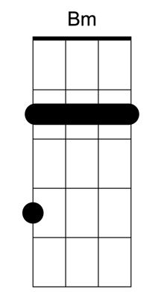

Intro: G Em C G

G Em
If you should be the last autumn leaf
C G
Hanging from the tree
G Em
I'll still be here waitin' on the breeze
C G
To bring you down to me

Bm C
And if it takes forever
Bm Em
Forever it'll be
Bm C
And if it takes forever
D G
Forever it'll be

Interlude:
G Em C G
Bm C D G

G Em
And if you should be the last seed in spring
C G
To venture out a leaf
G Em
I'll still be here waitin' on the rain
C G
To warm your heart for me

Bm C
And if it takes forever
Bm Em
Forever it'll be
Bm C
And if it takes forever
D G
Forever it'll be

Radiohead - Creep

 | 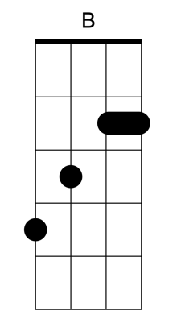 | 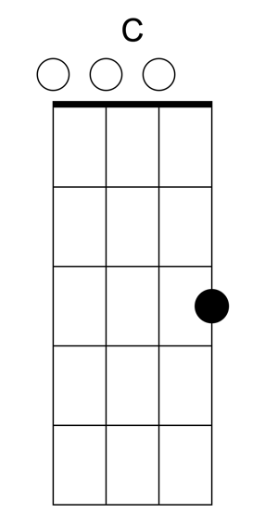 | 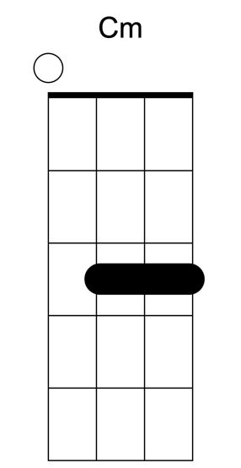

Whole song is

G B C Cm

All the way through, eight beats of each, ending on G.

When you were here before
Couldn't look you in the eye
You're just like an angel
Your skin makes me cry
You float like a feather
In a beautiful world
I wish I was special
You're so fuckin' special

But I'm a creep
I'm a weirdo
What the hell am I doing here?
I don't belong here

I don't care if it hurts
I wanna have control
I want a perfect body
I want a perfect soul
I want you to notice

When I'm not around
You're so fuckin' special
I wish I was special

But I'm a creep
I'm a weirdo
What the hell am I doing here?
I don't belong here
Oh, oh

She's running out the door
She's running out
She run, run, run, run
Run

Whatever makes you happy
Whatever you want
You're so fuckin' special
I wish I was special
But I'm a creep
I'm a weirdo
What the hell am I doing here?
I don't belong here
I don't belong here

The Tokens – The Lion Sleeps Tonight

Whole song: F Bb F C

A-wimoweh, a-wimoweh, a-wimoweh, a-wimoweh
A-wimoweh, a-wimoweh, a-wimoweh, a-wimoweh
A-wimoweh, a-wimoweh, a-wimoweh, a-wimoweh
A-wimoweh, a-wimoweh, a-wimoweh, a-wimoweh

In the jungle, the mighty jungle
The lion sleeps tonight
In the jungle, the quiet jungle
The lion sleeps tonight

A-wimoweh, a-wimoweh, a-wimoweh, a-wimoweh
A-wimoweh, a-wimoweh, a-wimoweh, a-wimoweh
A-wimoweh, a-wimoweh, a-wimoweh, a-wimoweh
A-wimoweh, a-wimoweh, a-wimoweh, a-wimoweh

Near the village, the peaceful village
The lion sleeps tonight
Near the village, the quiet village
The lion sleeps tonight

A-wimoweh, a-wimoweh, a-wimoweh, a-wimoweh
A-wimoweh, a-wimoweh, a-wimoweh, a-wimoweh
A-wimoweh, a-wimoweh, a-wimoweh, a-wimoweh
A-wimoweh, a-wimoweh, a-wimoweh, a-wimoweh

Hush my darling, don't fear my darling
The lion sleeps tonight
Hush my darling, don't fear my darling
The lion sleeps tonight

A-wimoweh, a-wimoweh, a-wimoweh, a-wimoweh
A-wimoweh, a-wimoweh, a-wimoweh, a-wimoweh
A-wimoweh, a-wimoweh, a-wimoweh, a-wimoweh
A-wimoweh, a-wimoweh, a-wimoweh, a-wimoweh

