Task 1
Discuss with your partner; which sentence is easier to read?
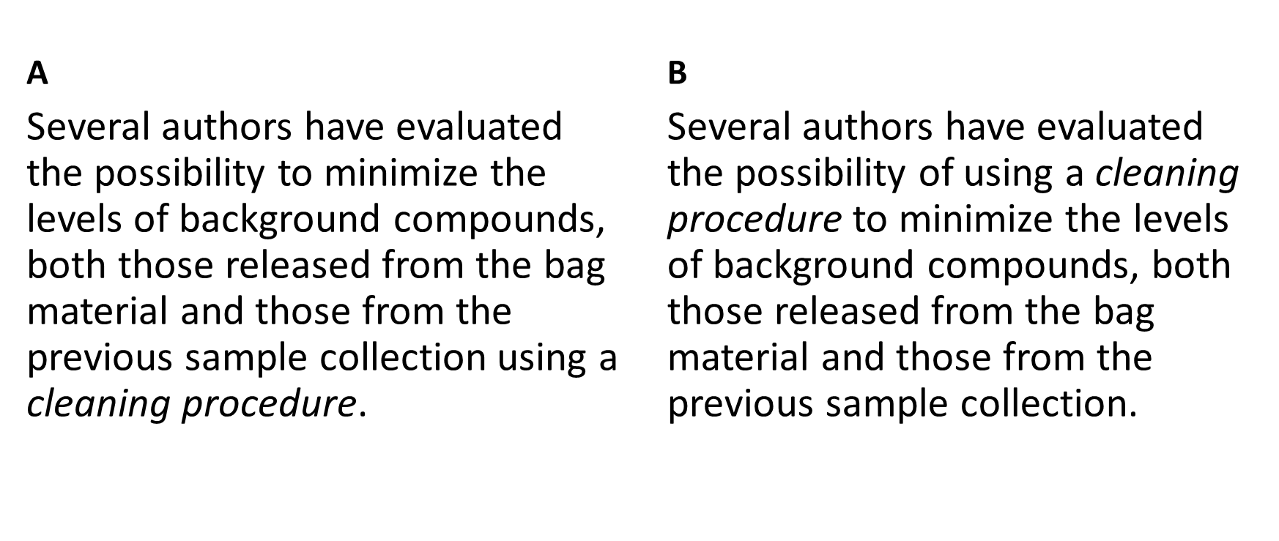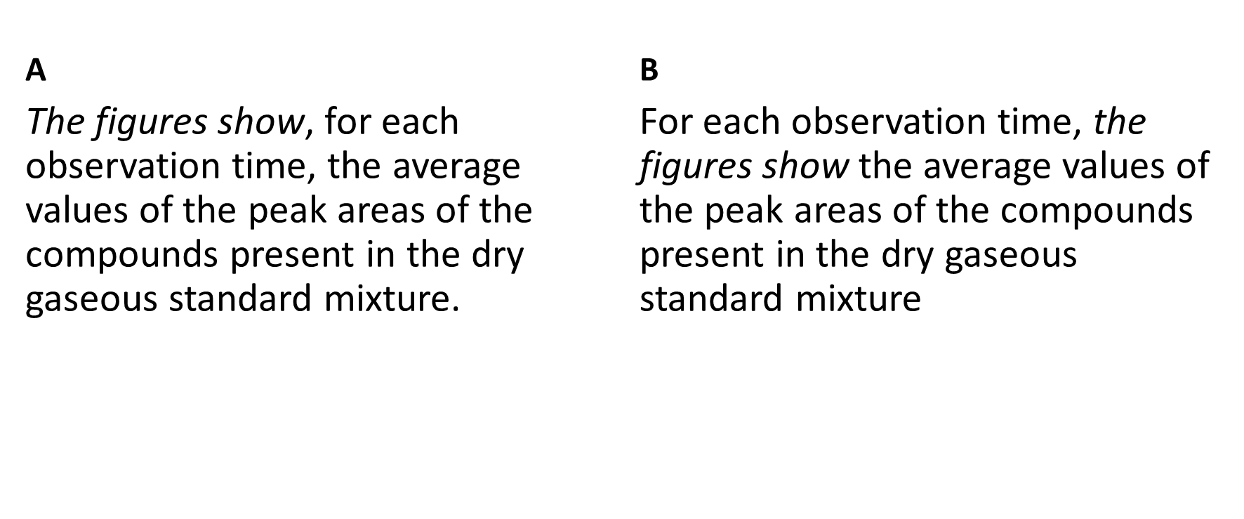
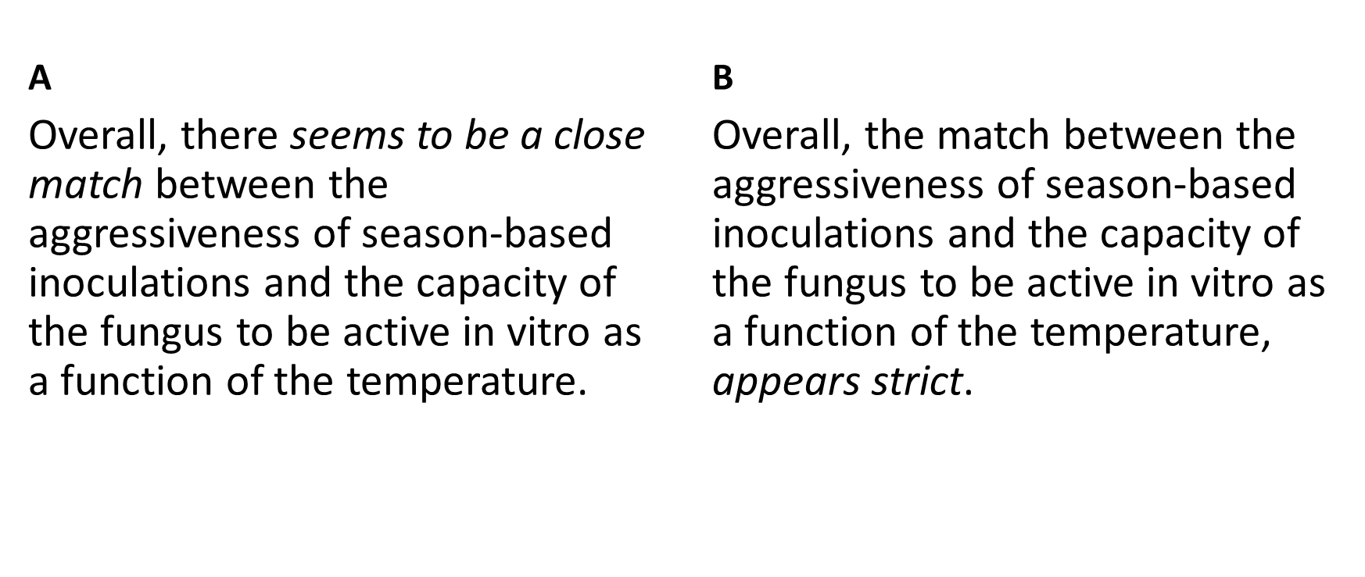

Task 2
How would change these sentences to make them correct or easier to read?
- In the survey participated 350 subjects.
- Were used several different methods in the experiments.
- With these values are associated a series of measurements.
- Once verified the nature of the residues …

Task 3
What is the common problem in these sentences?
- Among the factors that influence the choice of parameters are time and cost.
- Of particular interest was the sugar transporter, because…
- Important parameters are conciseness and non-ambiguity.

Task 4
How can we improve these sentences using modal verbs?
- It is probable that this is due to poor performance.
- It is possible to do this with the new system.
- It is mandatory to use the new version.

Task 5
How can we improve these sentences?
- This sampling method, when it is possible, is useful because it allows…
- These steps, owing to the difficulties in measuring the weight, require some simplifications.

