“Organoid” Culture: The Next Generation Tissue Culture Method in Biology

The use of traditional two-dimensional cell culture method has been met with multiple limitations in biological experiments. This has prompted the development of various innovative, next generation three-dimensional culture system in recent years. The effort in establishing such culture methodology is primarily aimed to more accurately recapitulate the in vivo physiological processes and biological interactions. This culture system is also commonly termed ‘organoid cultures’. In the field of cancer biology, such three dimensional organotypic culture models hold great promise as a tool for cancer precision medicine, with multiple applications for genetic studies, drug discovery and therapeutic experiments. In this seminar, I will present a few established protocols used to culture mouse or human pancreas, mammary glands and prostate. I will also discuss the current and potential applications of such culture methods as well as their limitations and future outlook.

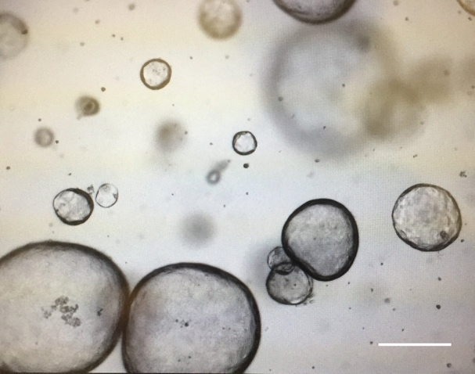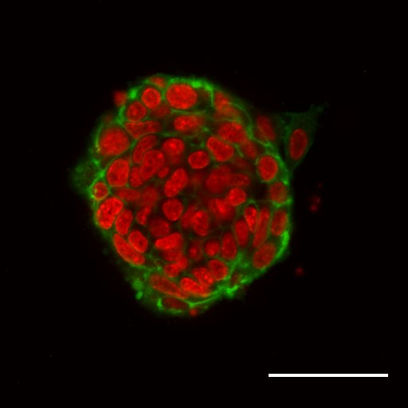
Murine pancreatic organoids (left) and murine mammary organoid (right) stained with smooth muscle actin (green) and E-cadherin (red). Images generated from Cold Spring Harbor Laboratory.

