

Surface Sciences Seminar

SPEAKER

**Prof. Katsuhiko Ariga**

World Premier International (WPI) Center for Materials Nanoarchitectonics (MANA)

National Institute for Materials Science (NIMS), Tsukuba, Japan

l.ono@inano.au.dk

**OIST Seminar**

Okinawa Institute of Science and Technology

MCBD14521_0000[1]MCBD14521_0000[1]

**Hand-Operating Nanotechnology:**

**Can we control molecular machines by our hands?**

Thursday, October 2, 2014 14:00 - 15:00

@ Meeting Room Lab 1 [C016]

MCBD14521_0000[1]MCBD14521_0000[1]

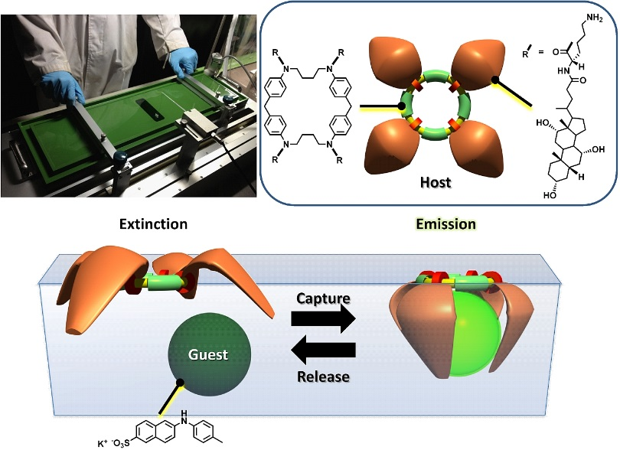**Abstract:** Here we propose a novel methodology “hand-operating nanotechnology” where molecular orientation, organization and even functions in nanometer-scale can be operated by our macroscopic (hand) operation. This concept can be realized at dynamic two-dimensional medium such as thin films at the air-water interface because this medium possess both features of bulk and molecular dimension. For example, we successfully manipulated molecular machines at the air-water interface upon bulk (10-100 cm size) motion of the entire monolayer and realized “capture and release” of aqueous guest molecules using molecular machine, steroid cyclophane (see Figure). In addition, mechanically controlled chiral recognition of amino acid and discrimination of nucleosides by the supramolecular monolayer was successfully demonstrated. The concept has been also applied to indicator-displacement assay for sensor usage.

These examples demonstrate our new concept, manual nanotechnology so-called, hand-operating nanotechnology, with which we can manually control nano/molecular phenomena and functions by macroscopic mechanical force such as hand motions. Using hands for functional operation would be most environmentally friendly and least energy consuming technology.

**References**

*Adv. Mater.* **25** 6477-6512 (2013) (Invitation to Journal 25th Anniversary Publication).

*Chem. Mater.* **26**, 519-532 (2014) (Invitation to Journal 25th Anniversary Issue).

**Short Biography:** Prof. Ariga is the Group Leader for Supermolecules Group at NIMS. He has published around 500 papers, is a Fellow of the Royal Society of Chemistry, and serves on editorial boards for many journals, including Advanced Materials, Chemistry of Materials, and Langmuir. He is listed as one of the most highly-cited researchers in Materials Science in 2014 (Thompson Reuters).

For more information

Energy Materials and Surface Sciences Unit, OIST

Tel: (098) 966-1516 Fax: (098) 966-1062

Ayako Masaki mailto: ayako.masaki@oist.jp