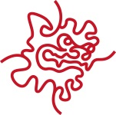 SEMINAR

Advanced Control for Modern TEM Operation.

Speaker:
Dr. Chen Xu

Brandeis University, MA, USA
-------------------------------------------------------------------------------------
Date: Friday, August 1st, 2014
Time: 11:00 – 12:00(Noon)
Venue: C016, Lab1, Level C
------------------------------------------------------------------------------------

Abstract:
In today's digital world, modern Transmission Electron Microscopes and electron image detectors are all computer controlled. This provides the possibility to have advanced control for specific TEM applications. For single particle and tomography applications in the CryoEM field, the current technology and available advanced tools are discussed for these TEM tasks. A user community based software system, SerialEM is introduced to give examples what we can do to run the microscope in more efficient ways.

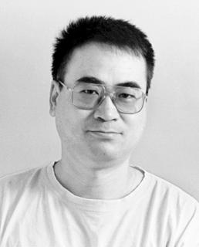

Molecular Cryo-Electron Microscopy Unit (Wolf Unit)

