Seminar

Title:
High resolution electron microscopy of biological structures: How we got here, where we are, and where we're going.

Speaker:
Prof. David J. DeRosier
Professor of Biology, Emeritus
Brandeis University, MA, USA
------------------------------------------------------
Date: Thursday, January 30th, 2014
Time: 13:00 – 14:00
Venue: C209, Center Bldg., Level C
------------------------------------------------------

Abstract:
Prof. David DeRosier is one of the founders of structural biology using electron microscopy. Together with Aaron Klug, he developed the method of reconstructing 3D images from electron micrographs and generated the first 3D image in this case of a T4 phage tail. Among many other achievements, he developed computer programs for the 3D processing of images of helical specimens. His talk promises to be very exiting – he will give us first accounts from his rich scientific life leading to the current state-of-the-art of biological cryo-EM and conclude with a glimpse into the future.

Everyone interested in the general field of structural biology and/or electron microscopy is highly encouraged to attend this unique opportunity!
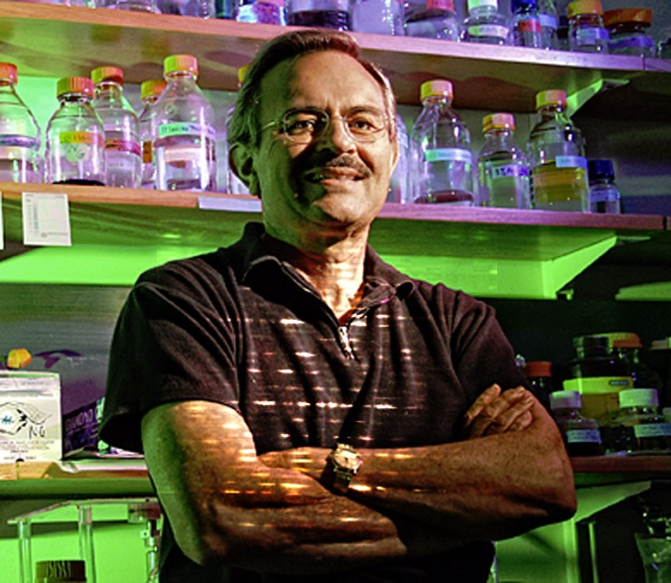

Molecular Cryo-Electron Microscopy Unit (Wolf Unit)

